Trello Workflow:
- When I subscribed and opened the Trello board, under the “Requests (QUEUE)” column I don’t see the Card example from my template:
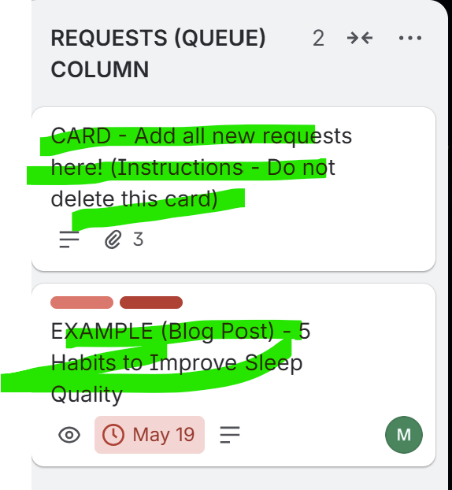
- The labels are not created under that template either:
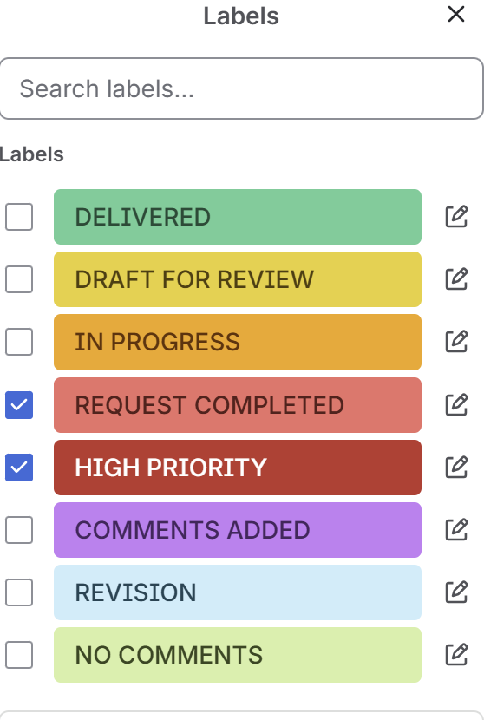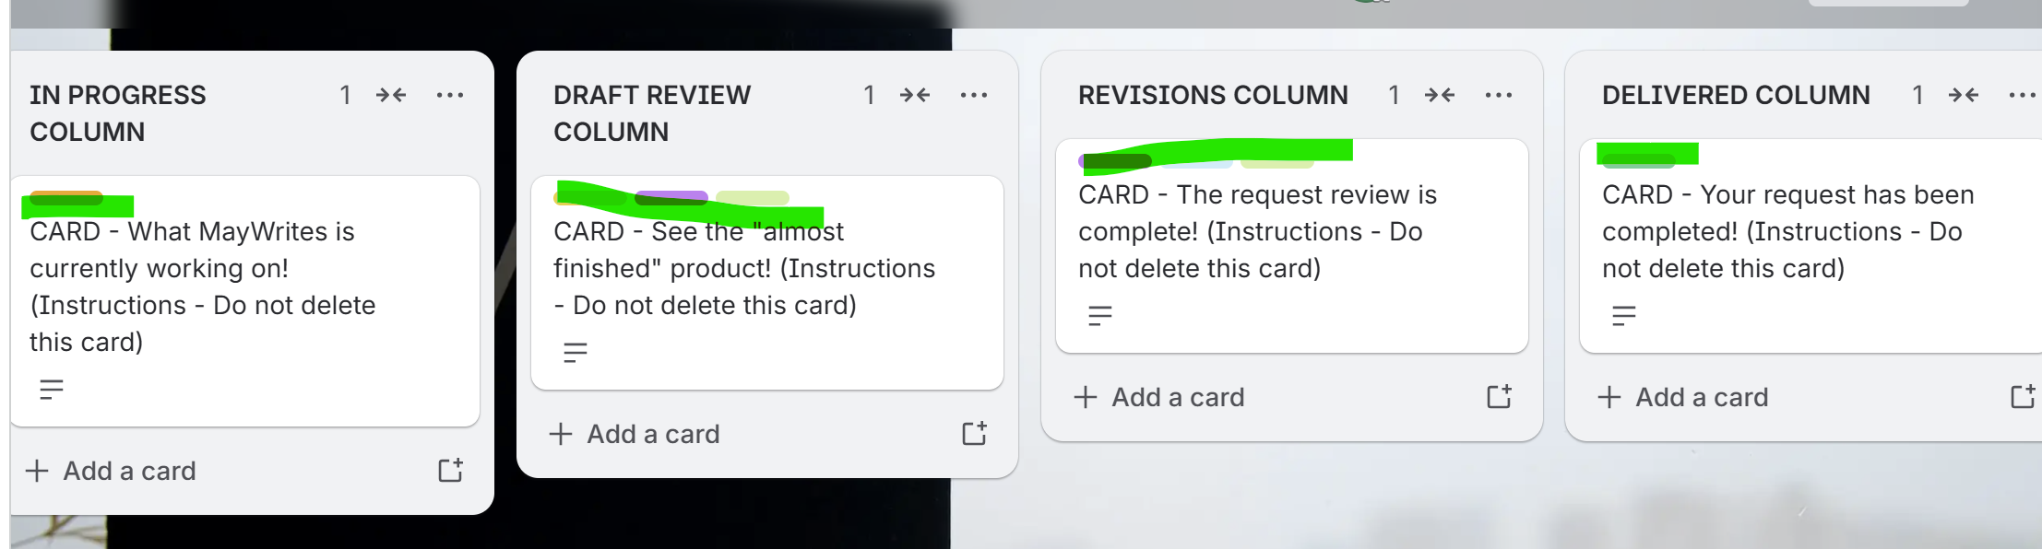
- This card shouldn’t be in the template:
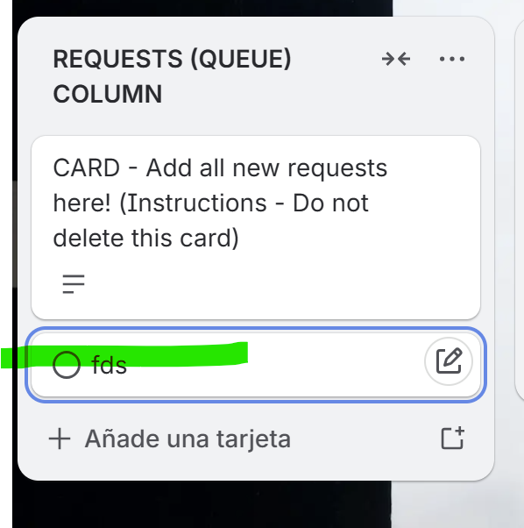
- Maybe this should just be a “Welcome” title for the column:
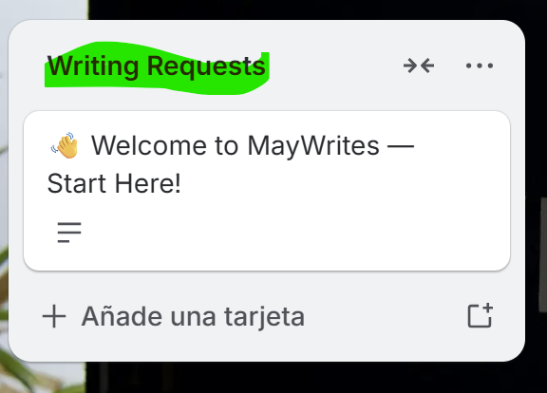
- And the description should only be the welcome message:
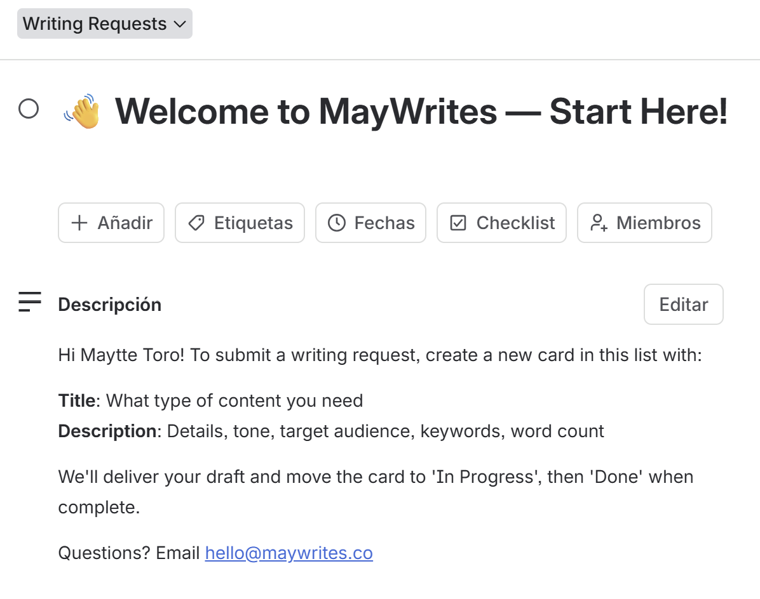
- The photos under this card are not visible:
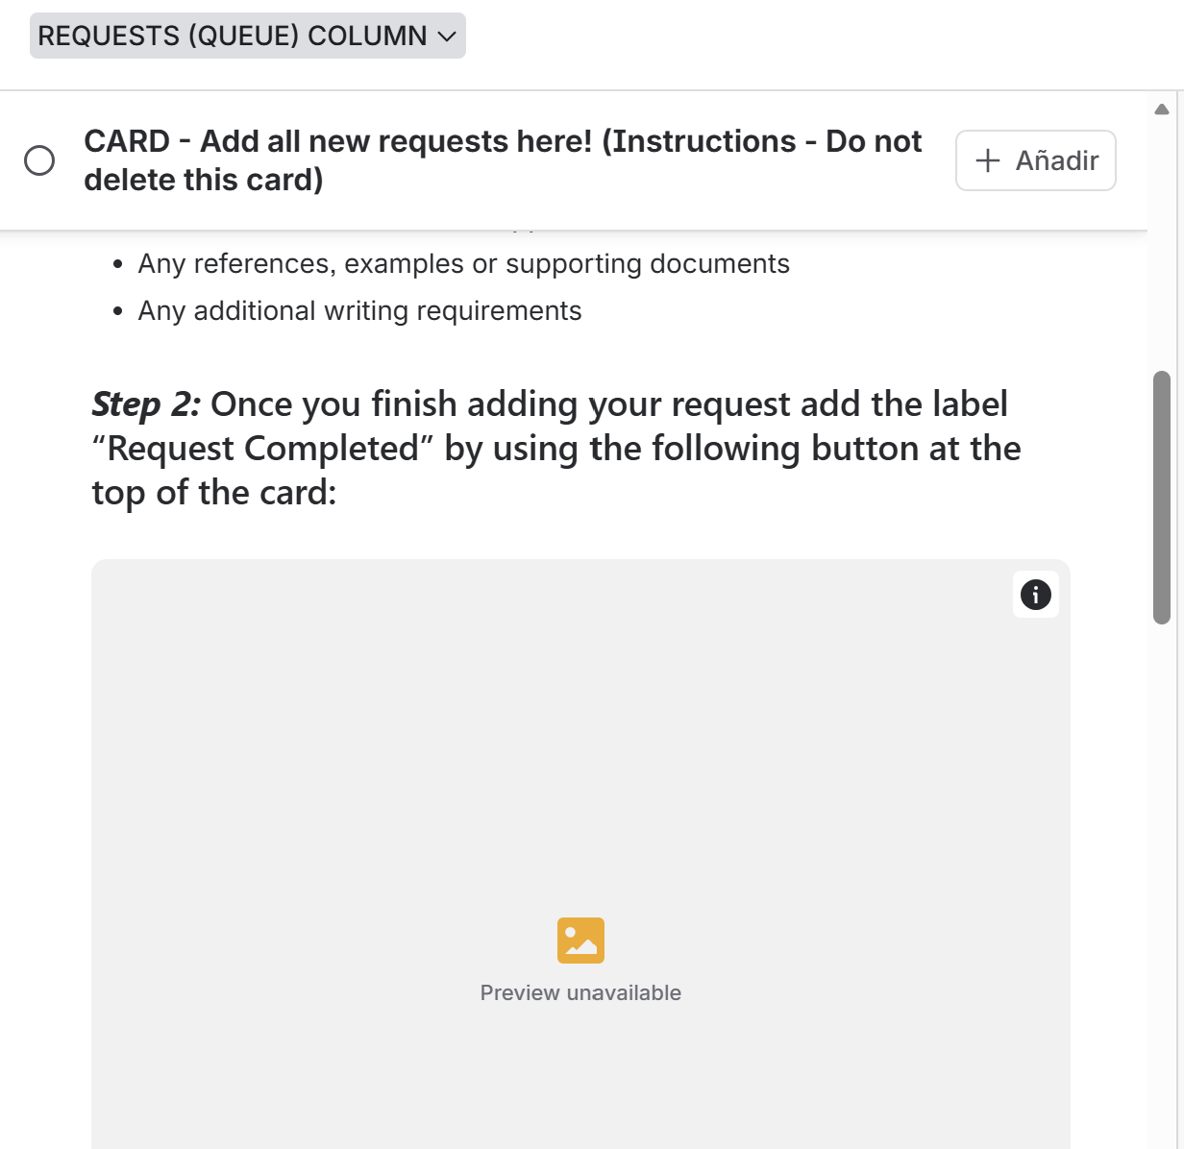
- Additionally, I didn’t receive the welcome email once I subscribed throughout Stirpe, and this time, I didn’t receive the Trello board invitation.
- How exactly do I get a notification in the admin board that a client has submitted a new request?
- Once I downloaded the generated document I requested, the document seems to only have the instructions of the request.
- Is it possible to generate the document once, and only the client label’s the card “Request Completed”:

That can ensure that the request is more precise and everything the client wants for the written content is there.
Website comments:
Comments:
- Can this be centered?
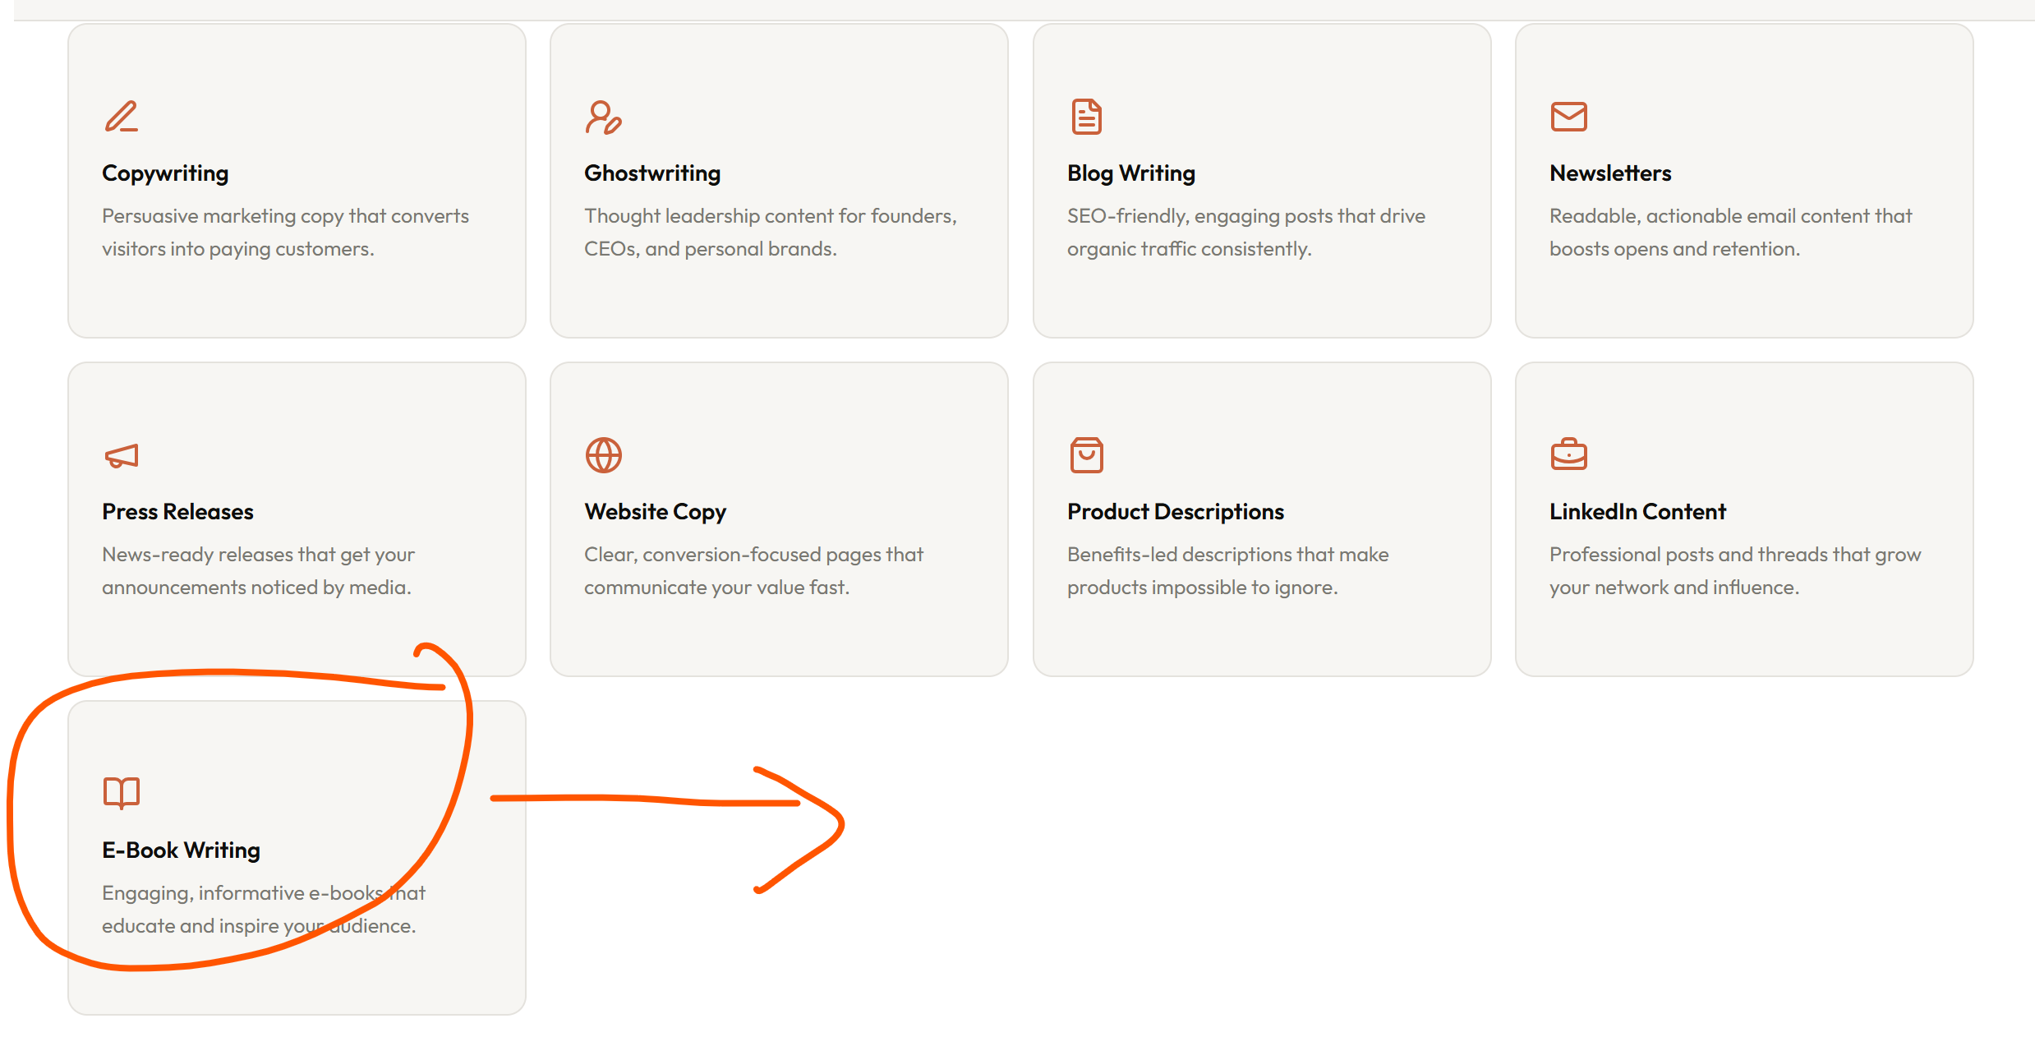
- Instead of “Same-day turnaround”, it should read “Priority turnaround”:
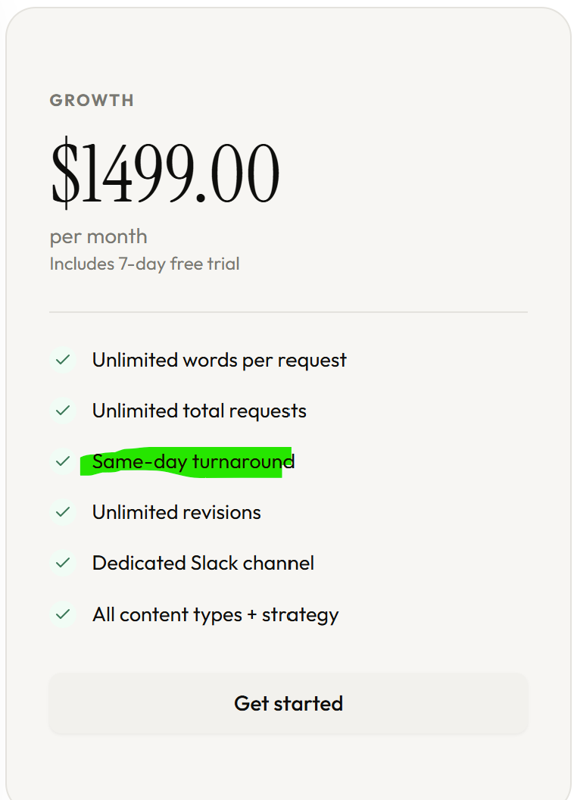
- Pleas put the ideal customer for each subscription:
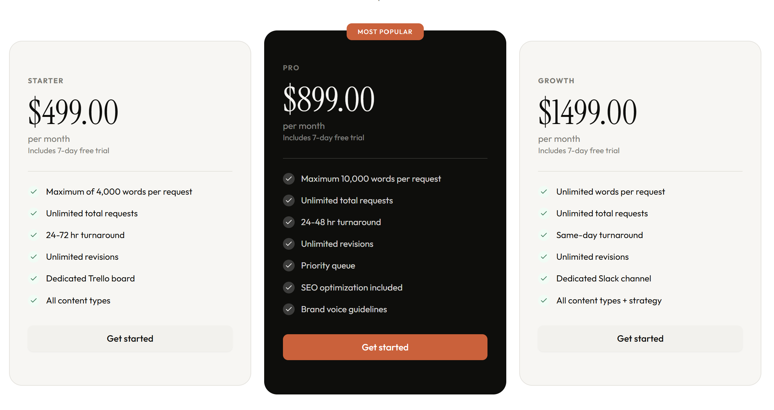
- STARTER
Ideal for individuals, creators, and small businesses that need consistent short-form content like LinkedIn posts, emails, captions, and simple blog articles.

- PRO
Perfect for growing brands and professionals that need consistent, high-quality content with stronger storytelling, strategy, and faster turnaround.

- GROWTH
Built for brands with higher content demands that need long-form content, ongoing campaigns, advanced strategy, and priority delivery.
- For the following question please specify that when canceling a subscription their Trello board will remain active until expiration day
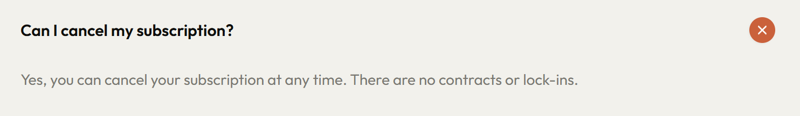
- Can you explain how the dedicated slack channel will work? 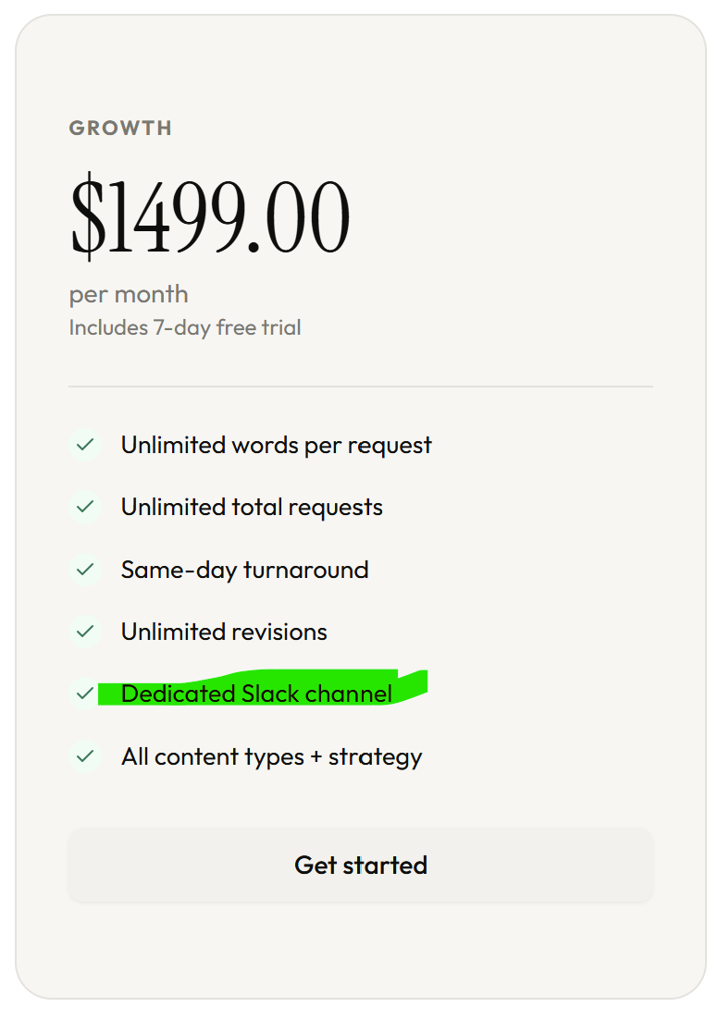
- While testing the stripe feature, I didn’t receive the welcome email, I only received the board invitation.
- This is the board title that the system made:
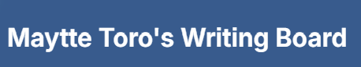

Is it possible to add the subscription plan chosen by the client?

Example: “Maytte Toro’s PRO Writing Board”

- After I signed up to Trello using the email entered on card, the board template is not the one I had set up

